List of available countries with JEPQ item-data

The “no. of items” following a country indicates the items referenced in the 97-item or 8- item questionnaire (both of which are provided in the subdirectory “Questionnaires”). Sometimes, like Catalan, a greater number of items were used (108). In these cases, it’s impossible to know which specific 97 or 81-item text-strings the item numbers refer to without accessing the original Catalan JEPQ publication and hoping it provides the 108-item questionnaire.

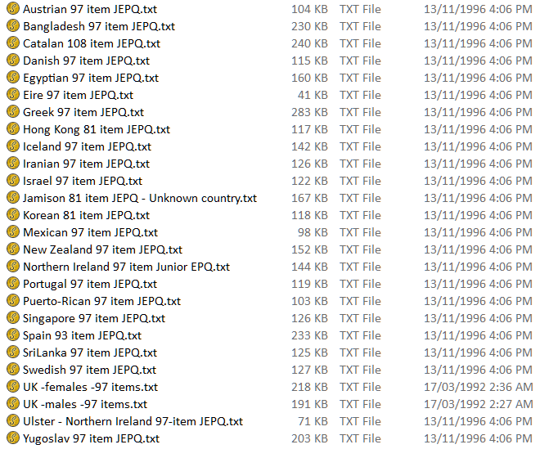

All data files are Fortran fixed-format ASCII plain text.

The questionnaire raw item responses are always coded:
3 = Yes, 1 = No. With a missing, spoiled, or otherwise uncertain response coded as a 2.

List of available JEPQ scorekeys

The “no. of items” following a country indicates the items referenced in the 97-item or 8- item questionnaire (both of which are provided in the subdirectory “Questionnaires”). Sometimes, like Hungary, a greater number of items were used (110). In these cases, it’s impossible to know which specific 97 or 81-item text-strings the item numbers refer to without accessing the original Hungarian JEPQ publication and hoping it provides the 110-item questionnaire.

In the Word document: Additional Junior EPQ Scorekeys, Jan, 2020.docx
Austria – 97 items
Denmark – 97 items
Greece – 97 items
Hong Kong – 81 items
Hungary - 110
Japan – 96 items
Northern Ireland – 97 items

In the document scans: Scanned JEPQ scorekeys, Jan, 2020.pdf
Korean – 81 items
Singapore – 97 items
Sri Lanka – 97 items
Yugoslavia – 97 items

Old Fortran “Score” program job-control files
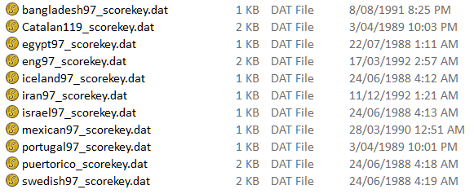

These “Score” program scorekey files are Fortran fixed-format ASCII plain text files, with the explanation of the scorekey information in the file provided on the next page.

The old Fortran “Score” program scorekey job-control definitions

LINE 1 .... TITLE (up to 80 chars.)
LINE 2 .... col. 1-4 ...the number of variables in the test (I4)
col.5........ = 2 (a fixed constant)
col. 6-7 ... The number of scales in the test
col. 8 ...... 2-9 = the fixed number of response categories for every item
col. 9-10 ... the value to be assigned to any missing response (defaults now to the
lowest scored value)
col. 11-12 .. the maximum number of missing responses permitted before a
WARNING message is printed - for each subject.
col. 13-14 <NGR> 0 = no age grouping requested
or from 01-60 = from 1 to 60 age groups requested.
col. 15-16 <IRL and IRH> … the lower and upper score range (2I1)
_______________________

IF age grouping requested, THEN THE NEXT LINE/S CONTAIN
*
LINE 3 ... col. 1-2 <LOW(1)> lower bound for age group 1
col. 3-4 <IHI(1)> upper bound for age group 1

LINE 4 ... col. 1-2 <LOW(2)> lower bound for age group 2
| col. 3-4 <IHI(2)> upper bound for age group 2
|
LINE N ... col. 1-2 <LOW(n)> lower bound for age group n
col. 3-4 <IHI(n)> upper bound for age group n
___________________________

NEXT LINE ... the scales names, 8 chars per name, 10 names to a line. (10A8)

NEXT LINE ... the number of items in each scale, 2 digits per number, no spaces or commas between each 2 digit number. (40I2)

NEXT LINE ... the actual item numbers/position in the data. Usually the items are keyed in the order they appear in the questionnaire, thus the item numbers are those in the questionnaire. Up to 26 item numbers can be entered on each line, each number is 3 digits long. Each set of items for each new scale start on a new line. (26I3)

NEXT LINE ... the names of the response categories, 8 chars per name with up to 9 categories on the line. These will match the order of your response score-key values below.

NEXT LINES ... for each item. a 2-digit code is entered for each possible response, indicating the scored value for that particular response category on that particular item. Thus if there are three categories of response on an item, say NO, NO ANSWER, and YES, corresponding to the raw data values of 1, 2, and 3, then the 2 digit codes might be 000001 if scoring the YES response with a value of 1 and the other responses as 0. For a 90-item test, there would be 90 such lines of data. If you had a different number of responses for each item, then you would put in as many codes as required per item. The order of the item codes must match the order of the item numbers entered above for each scale. The order of the scales must be the same as entered above.
THEN, a line indicating:
- The number of lines in the data file containing the raw data (i2)
- The beginning column and end column for each line of data (i2)
So, a line say of “0211801137” would indicate two lines of data, 1st line beginning in column 11 and ending in column 80, 2nd line column 11, ending in column 37 (for a 97-item dataset)

THEN, a line for each Fortran format statement reading the data in the data file.

